* It is used when the smallest or biggest element from a group of items.
* Applications are also found in discrete optimization (Bin packing, scheduling) and event driven simulation. ( Customers in a line, Colliding Particles.)
* Example is coded as file UnorderedMaxPQ.java.
* Takes constant time to insert and linear time to del max item.
* A complete binary tree is one which is completely balanced except the one at the bottom level.

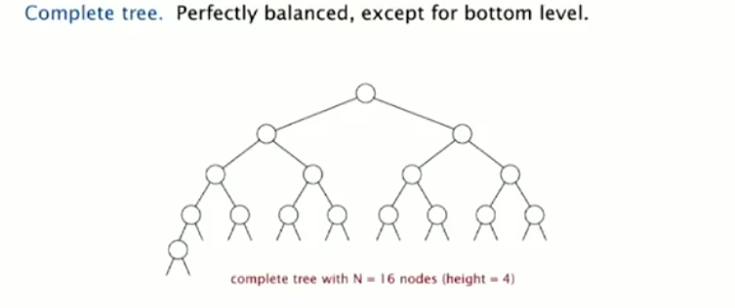

* Conventions:
  + The parents key(value at the node) cannot be smaller than the value of its children.
  + We leave the 0 index empty and start from array index 1 which has the root and the last indices have the leafs.
  + Index of a parent in the array will always be the integer division value of its child.
* Considerations:
  + It is better if the keys in the heaps are immutable.
  + This can be done by instance method as shown in the figure below:

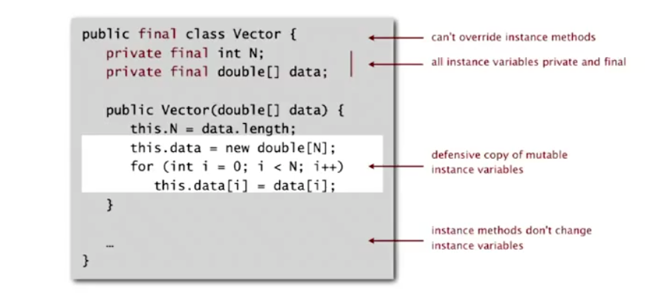

* Example of PQ by binary tree:
* 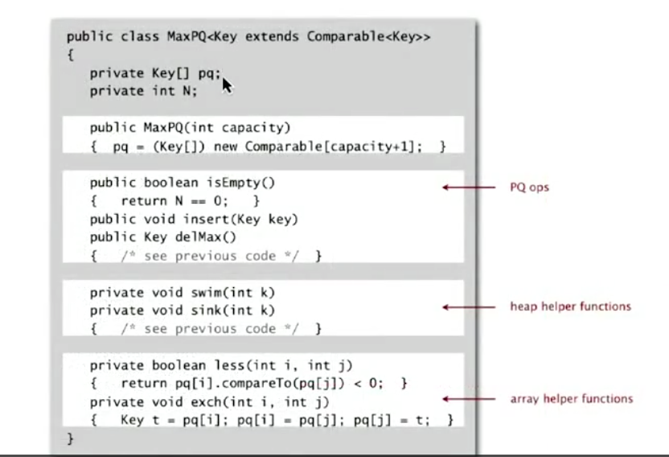
* Is an in place sorting algorithm.
* It does the job in guaranteed O(NlogN) times.
* The trace is as follows:
* 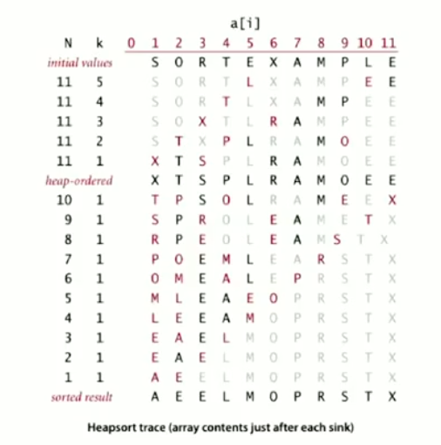
* Disadvantages:
  + Inner loops are longer than quicksort’s.
  + Makes poor use of cache memory.
  + Not Stable.